**Lesson 1 About Servo**

MaxArm uses three HTS-35HV and one LFD-01M digital servos in total.

## **HTS-35H Bus Servo**

## **1.1 Servo Introduction**

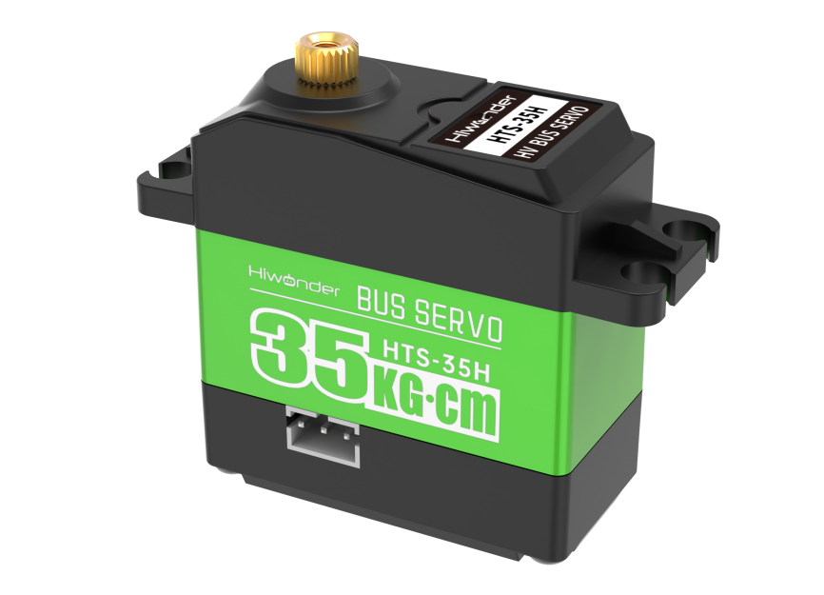

HTS-35H bus servo is controlled by serial port commands. The serial port baud rate is 115200. Servo parameters and ID are required to be set before controlling.

The interface of this servo is a half-duplex UART asynchronous serial interface so that the signal terminal can send and receive signals. It is widely applicable to different robotic arm joints.

## **1.2 The Reason for Using HTS-35H Servo**

MaxArm is linkage mechanism in machine construction so it needs to use strong torque and single shaft servo with high precision positioning capability. HTS-35H high voltage servo can totally meet these requirements and reduce the current by 60％ to increase the battery lift and insist on environmental friendly principle.

## **1.3 Port Instruction**

The port uses anti-reverse plug so do not insert it violently. The pin instruction is shown in the following list:

|  |  |
| --- | --- |
| **PIN** | **PIN Instruction** |
| GND | GND |
| VIN | Power input |
| SIG | Signal terminal, half-duplex UART asynchronous serial interface |

## **1.4 Parameter Instruction**

|  |  |
| --- | --- |
| Working voltage | DC 9-12.6V |
| Rotation speed | 0.18sec/60°(DC 11.1V) |
| Torque | 35kg.cm (DC 11.1V) |
| Maximum static torque | 35kg.cm (DC 11.1V) |
| Rotation range | 0~ 240° |
| No-load current | 100mA |
| Stall current | 3A |
| Servo accuracy | 0.2° |
| Angle control range | 0-1000 corresponds to 0~ 240° |
| Control method | UARTUART serial port command |
| Communication baud rate | 115200 |
| Storage | Servo settings are automatically saved when power off |
| Servo ID | 0-253 can be set by user. It defaults to ID1. |
| Readback function | Support angle readback |
| Protection | Avoid stalling and overheat |
| Parameter feedback | Temperature, voltage and position |
| Working mode | Servo mode and gear motor mode |
| Gear type | Metal gear |
| Servo Wire | 20cm, other lengths can be selected |
| Plug-in model | PH2.0-3P |
| Weight | 64g |
| Size | 54.38mm*20.14mm*45.5mm |
| Application | All kinds of bionic robot joints |

## 1.5 Communication Protocol

Servo uses asynchronous serial bus communication method. Theoretically, up to 253 robot servos can be connected into chain through the bus and they can be you can be uniformly controlled through the UART asynchronous serial interfaces. Each servo can be set as a different node address so multiple servos can be unified or controlled independently.

Communicating with user's host computer software(controller or PC) through the asynchronous serial interface, you can set parameters and control function. Sending instructions to servo through the asynchronous serial interface, the servo can be set to the motor control mode or position control mode. In the motor control mode, servo can be used as a DC geared motor with adjustable speed; In the position control mode, servo can rotates between 0 and 240 degrees with Plus ± 30 ° deviation adjustable range. Within this range, servo has precise position control performance and adjustable speed.

# **LFD-01M Servo**

## 2.1 Servo Introduction

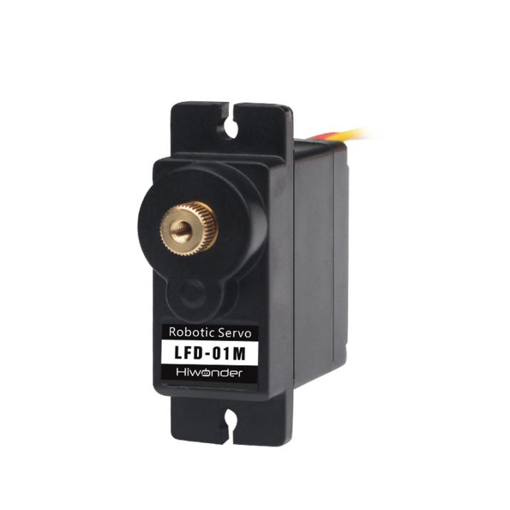

Compared with other 9g servos on the market, Hiwonder LFD-01M 9g servo has a built-in anti-blocking protection algorithm to prevent burning out caused by locked-rotor or collision, which significantly extends the service life. All metal gears of this servo are optimized to be smooth and durable.

It is widely applicable in DIY design for smart car, robot and robotic arm.

## 2.2 The Reason for Using LFD-01M Servo

When controlling the position of nozzle suction, MaxArm should be stable and smooth. All gears of LFD-01M servo are optimized to be smooth and durable, which can get better user experience.

## 2.3 Port Instruction

|  |  |
| --- | --- |
| **PIN** | **Instruction** |
| Brown cable | Ground cable |
| Red cable | Positive pole of power supply |
| Orange cable | Signal cable |

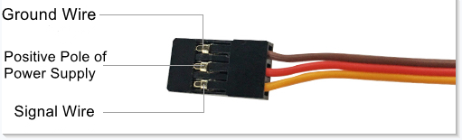

## 2.4 Parameter Instruction

|  |  |
| --- | --- |
| Working Voltage | DC 4.8-6V |
| No-load Current | 50mA |
| Stall Current | 700mA |
| Control Method | PWM pulse width control |
| PWM Pulse Width | 500~2500μs corresponds to 0~180° |
| Rotation Speed | 0.12sec/60°4.8V 0.10sec/60°6V |
| Stall Torque | 1.5KG.cm 4.8V 1.8KG.cm 6V |
| Rotation Range | 0~180° |
| Gear Material | Metal Gear |
| Servo Wire | 26cm |
| Size | 32.5mm*12mm*29.85mm |
| Weight | 14g |
| Applicable to | All kinds of bionic robot joints |